Topology Qualifying Exam Fall 2023 - Solutions

Problems
- Let $X$ be a compact space and let $\{A_{n}\}_{n=1}^{∞}$ be a sequence of nonempty closed subsets of $X$ such that $A_{n+1}⊂A_{n}$ for all $n$. Prove that $∩_{n=1}^{∞}A_{n}$ is nonempty.
- Solution: Let $U_{n}=X∖A_{n}$. Then each $U_{n}$ is an open set since $A_{n}$ is closed, and $U_{n}⊂U_{n+1}$ since $A_{n+1}⊂A_{n}$. Suppose for contradiction that $∩_{n=1}^{∞}A_{n}$ was empty. This would yield
$$⌀=∩_{n=1}^{∞}\left(X∖U_{n}\right)=X∖∪_{n=1}^{∞}U_{n},$$
- and hence $∪_{n=1}^{∞}U_{n}=X$. Since $X$ is compact and the $U_{n}$ are open, it would follow that finitely many $U_{n}$ suffice to cover $X$, say $X=∪_{n=1}^{N}U_{n}$. But since $U_{n}⊂U_{n+1}$ we have $∪_{n=1}^{N}U_{n}=U_{N}$, so our contradiction assumption would imply that $X=U_{N}$ for some $N$, and hence that $A_{N}=X∖U_{N}$ is empty, contrary to the hypothesis that all of the $A_{n}$ are nonempty.
- Give an example of a continuous surjective function that is not an open map.
- Solution: Let $X=[0,1]∪[2,3]$ and $Y=[0,1]$, both with the subspace topology from the standard topology on $R$. Define $f$ by $f(x)=x$ when $x∈[0,1]$ and $f(x)=1/2$ when $x∈[2,3]$. This is clearly surjective, and is continuous by the pasting lemma. But $[2,3]$ is open in $Y$ while $f([2,3])=\{1/2\}$ which is not open in $[0,1]$.
- Let $G$ be the free group on two generators $a$ and $b$. Use covering space theory to find (giving an explicit description of the generators in terms of $a$ and $b$) a normal, index-three subgroup of $G$.
- Solution: Consider the covering space $X^{'}$ of $S^{1}∨S^{1}$ depicted in Figure 1, with the covering map $π:X^{'}→S^{1}∨S^{1}$ sending edges marked $a$ to one of the circles and edges marked $b$ to the other circle with orientations as indicated, and with the points at which ' $a$ ' and ' $b$ ' edges intersect (including the basepoint $p^{'}$ of $X^{'}$) mapping to the point of intersection $p$ of the two circles. This is a three-sheeted covering space, which is normal because successive rotations of the figure by $\frac{2π}{3}$ map any point in the preimage of $p$ to any other such point. Hence covering space theory implies that $π_{*}\left(π_{1}(X^{'},p^{'})\right)$ will be an index-three, normal subgroup of $π_{1}(S^{1}∨S^{1},p)$, the latter of which is the free group on two generators, one for each of the two circles.
- 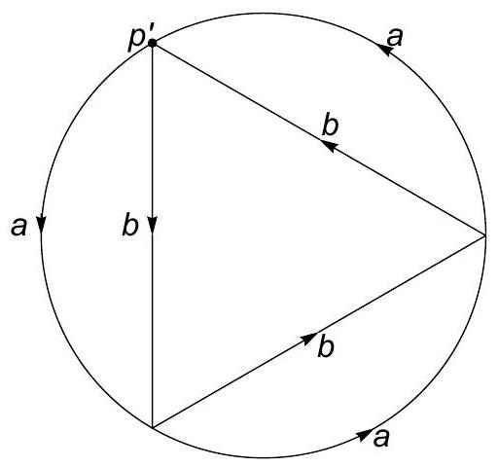
- Figure 1. Figure for solution to problem 3
- The space $X^{'}$ deformation retracts to a wedge of four circles (by contracting a maximal tree, which will consist of two edges, to a point), so its fundamental group is free on four generators; to see where these generators are mapped under $π_{*}$ we concatenate edge labels for appropriate loops based at $p^{'}$ in the diagram (with inverses when we go against the orientation of a path). There are various possible choices of sets of generators; one such is $\left\{ab^{-1},b^{3},bab,a^{-1}b\right\}$, as the associated loops in the diagram map to the four distinct circles in $S^{1}∨S^{1}∨S^{1}∨S^{1}$ under the quotient that collapses the two edges of the triangle with vertex $p^{'}$. Thus the desired index three normal subgroup of the free group on two generators is the one generated by $ab^{-1}$, $b^{3}$, $bab$, and $a^{-1}b$.
- Let $D$ denote the closed unit disk in $R^{2}$ with boundary $S^{1}$. Choose $p∈S^{1}$ and let $X$ denote the union $\left(S^{1}×S^{1}\right)∪(D×\{p\})$. Find the fundamental group and the homology of $X$.
- Solution: $X$ can be formed as a cell complex, consisting of the usual cell complex structure for the torus $S^{1}×S^{1}$ (with one zero cell $p$, two one-cells $a$ and $b$, and a single two-cell $e$ glued via the word $aba^{-1}b^{-1}$) together with an additional two-cell $f$ glued via $a$. The fundamental group therefore has presentation $\left\langle a,b∣aba^{-1}b^{-1},a\right\rangle$ which simplifies to $⟨b⟩$, i.e. the fundamental group is isomorphic to $Z$.
- For the homology we calculate the cellular chain complex $\left(C_{*},∂\right)$. (Write $∂_{k}$ for the restriction of $∂$ to $C_{k}$.) $C_{0}$ is generated by $p$, with $∂_{0}p=0$. $C_{1}$ is generated by $a$ and $b$, with $∂_{1}a=∂_{1}b=p-p=0$. $C_{2}$ is generated by $e$ and $f$, with $∂_{2}e=a+b-a-b=0$ and $∂_{2}f=a$. All other $C_{k}$ are 0. Hence $H_{0}(X)=\frac{ker∂_{0}}{Img∂_{1}}=⟨p⟩≅Z, H_{1}(X)=\frac{ker∂_{1}}{Img∂_{2}}=\frac{⟨a,b⟩}{⟨a⟩}≅Z, H_{2}(X)=\frac{ker∂_{2}}{Img∂_{3}}=⟨e⟩≅Z,$ and all other $H_{k}(X)$ are 0.
- Find, with proof, a choice of identifications in pairs between the edges of a regular octagon such that the quotient space is homeomorphic to the Klein bottle.
- Solution: There are multiple correct solutions to this problem. Any choice of identifications in pairs of the sides of an octagon yields a cell complex with four 1-cells and one 2-cell, while the number (say $c_{0}$) of 0-cells will depend on how the edges are identified. The Euler characteristic will thus be $c_{0}-4+1=c_{0}-3$, so since the Euler characteristic of the Klein bottle is zero we will need to have $c_{0}=3$. Up to homeomorphism, there are precisely two compact connected surfaces without boundary having Euler characteristic zero, namely the Klein bottle $K$ and the torus $T$. One way of distinguishing these is by the fact that $H_{2}(K)=0$ while $H_{2}(T)=Z$; in terms of the cellular chain complex this translates to the statement that the boundary of the 2-cell will be nonzero for $K$ and zero for $T$. So an edge identification will work as long as it results in exactly three equivalence classes of vertices, and the word in the one-cells formed by circulating counterclockwise around the octagon does not have all generators appear in canceling pairs.
- One way of achieving this is shown in Figure 2. Another valid way of arriving at that particular figure is by noting that $K≅RP^{2}\#RP^{2}$ and then gluing two presentations of $RP^{2}$ as the quotient of a square by the restriction to its boundary of a ${180}^{∘}$ rotation.
- 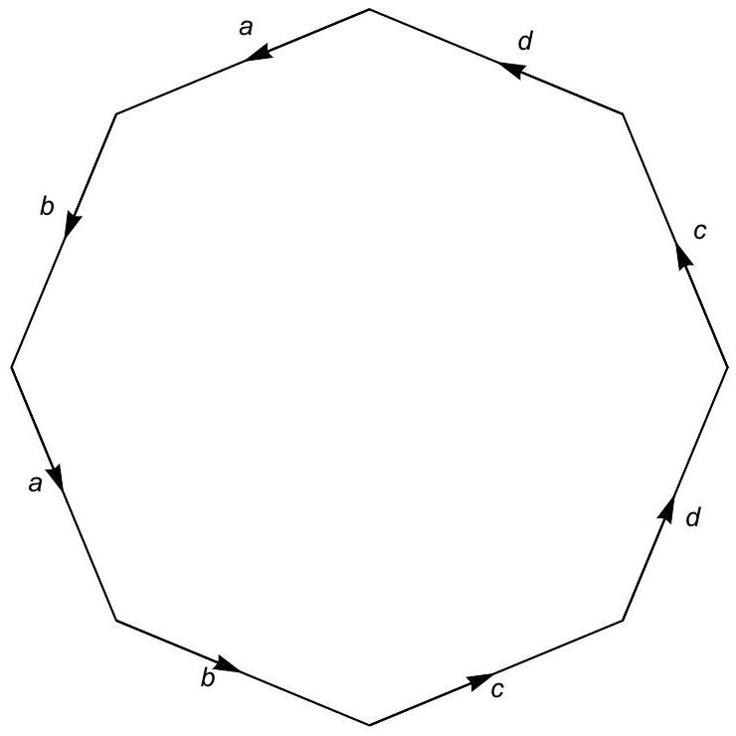
- Figure 2. Figure for solution to problem 5
- Prove that $R^{3}$ is not homeomorphic to $R^{4}$.
- Solution: Suppose that $f:R^{3}→R^{4}$ is a homeomorphism. Let $p=(0,0,0)∈R^{3}$ and let $q=f(p)∈R^{4}$. Then $f$ restricts to a homeomorphism from $R^{3}∖\{p\}$ to $R^{4}∖\{q\}$. But $R^{3}∖\{p\}$ deformation retracts on $S^{2}$ and $R^{4}∖\{q\}$ is homeomorphic to $R^{4}∖\{(0,0,0,0)\}$ which deformation retracts onto $S^{3}$. $H_{k}(S^{2})$ is 0 except when $k=0$ and $k=2$ while $H_{k}(S^{3})$ is 0 except when $k=0$ and $k=3$, so $S^{2}$ and $S^{3}$ cannot be homotopy equivalent, which leads to a contradiction.
- Recall that if $X$ is a space, the suspension of $X$ is the space $SX$ formed as the quotient of $[-1,1]×X$ by the relation that collapses both $\{-1\}×X$ and $\{1\}×X$ to points. Prove that for all $k$ there are isomorphisms ${\tilde{H}}_{k+1}(SX)≅{\tilde{H}}_{k}(X)$, where ${\tilde{H}}_{k}$ denotes $k$th reduced homology.
- Solution: Regard $SX$ as a quotient of the cone $CX$, which is itself formed from $[-1,1]×X$ by collapsing $\{-1\}×X$ to a point. Note that $CX$ is contractible and thus ${\tilde{H}}_{k}(CX)=0$ for all $k$. Then $SX$ is formed from $CX$ by collapsing $A=\{1\}×X$ to a point. Also note that $(CX,A)$ is a good pair, since the product structure gives an obvious neighborhood of $A$ that deformation retracts onto $A$. Thus $H_{k}(CX,A)≅H_{k}(CX/A,A/A)≅{\tilde{H}}_{k}(CX/A=SX)$. Now, since $CX$ is contractible, the long exact sequence for the pair $(CX,A)$ becomes a sequence of isomorphisms $H_{k}(CX,A)≅{\tilde{H}}_{k-1}(A)$ for all $k$. Since $A≅X$ we get the desired isomorphisms.
- Let $X$ be the standard 3-simplex and let $A$ be the 1-skeleton of $X$. Compute the relative homology $H_{k}(X,A)$ for all $k$.
- Solution: We will use the long exact sequence for the pair $(X,A)$ and note that $H_{k}(X)=0$ except when $k=0$, $H_{0}(X)=Z$ (because $X$ is contractible), $H_{k}(A)=0$ except when $k=0$ and $1$, $H_{0}(A)=Z$ and $H_{1}(A)=Z^{3}$ (because $A$ is a graph homotopy equivalent to a wedge of 3 circles). Thus for $k>2$, we have $0=H_{k}(X)→H_{k}(X,A)→H_{k-1}(A)=0$ and thus $H_{k}(X,A)=0$. For $k=2$ we have $0=H_{2}(X)→H_{2}(X,A)→H_{1}(A)=Z^{3}→H_{1}(X)=0$ and thus $H_{2}(X,A)=Z^{3}$. For $k=1$ we have $0=H_{1}(X)→H_{1}(X,A)→H_{0}(A)=Z→H_{0}(X)=Z$ but we know that this last inclusion-induced map is an isomorphism and thus $H_{1}(X,A)=0$. Lastly $H_{0}(X,A)=0$ because of this same isomorphism (or because $H_{0}(X,A)$ is always 0 when each path component of $X$ contains a path component of $A$).

